Logic apps: logic apps is used whenever pipeline fails and you want be informed on mail

1. Go search logic apps in search bar
2. Go to logic apps create

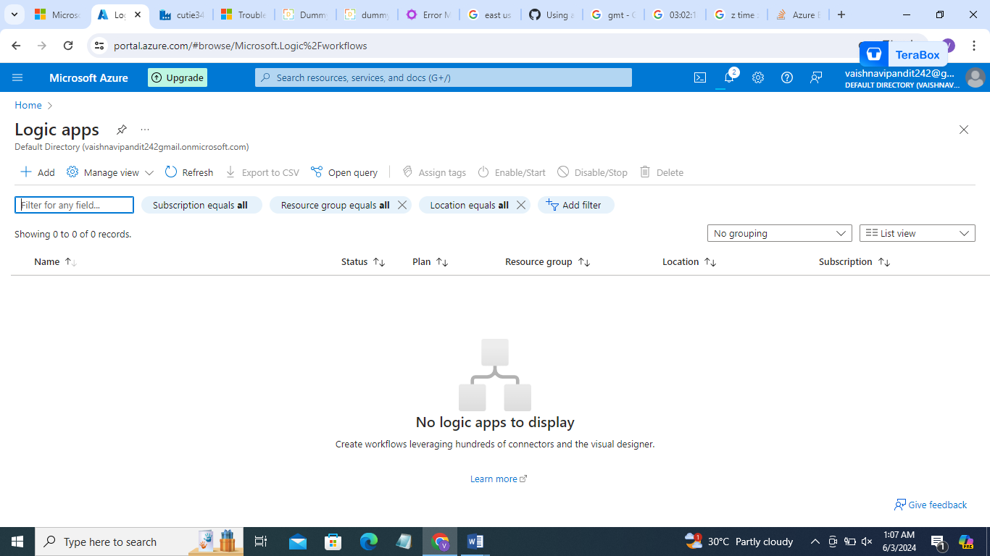

1. Go to add

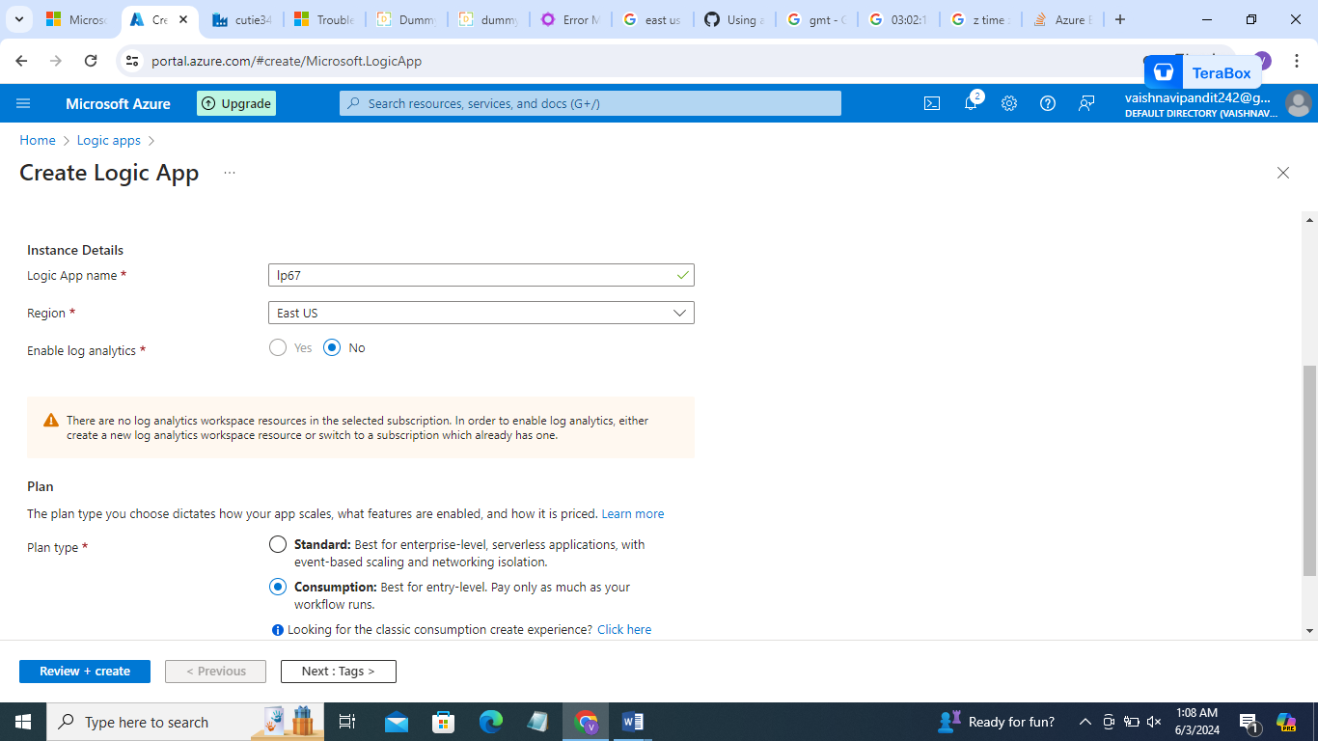

1. Now go to azure data factory and create a pipeline for practice which will give error
2. Now create variables

Pipelinename

Datafactoryname

Pipelineid

message

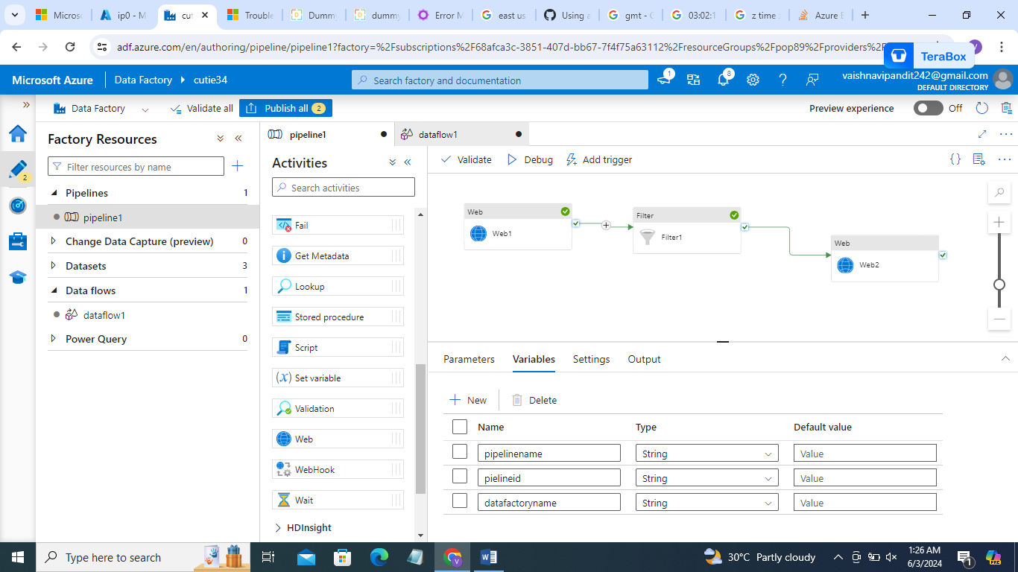

1. Go to pipeline and create set variable activity for variables pipelinename, datafactoryname, pipeleineid

For value go to add dynamic contains->systemvariable->select piplinename,pipelineid,datafactory id respectively

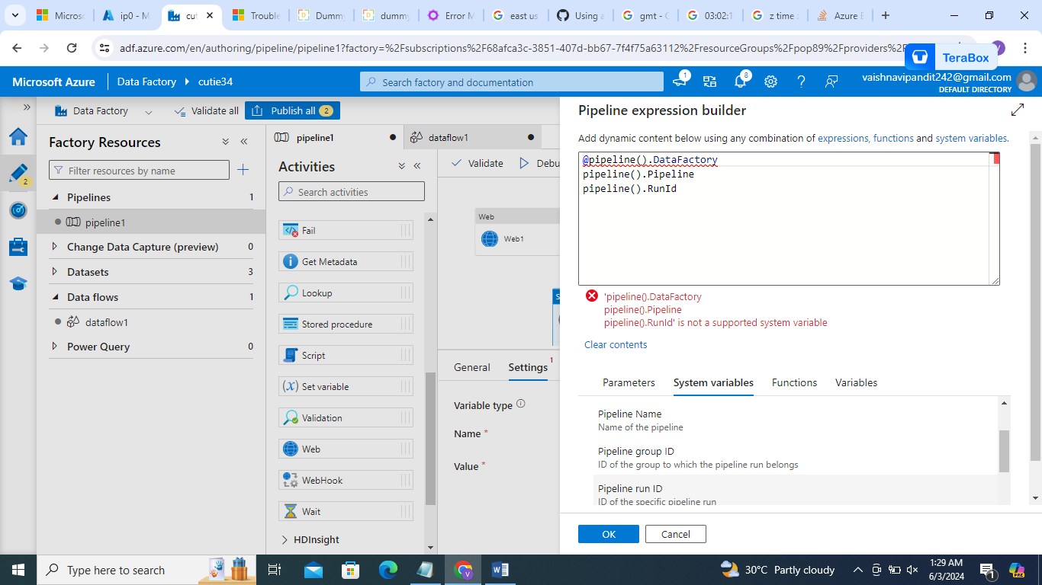

1. Copy these values and delete the activities
2. Now create set variable activity for message

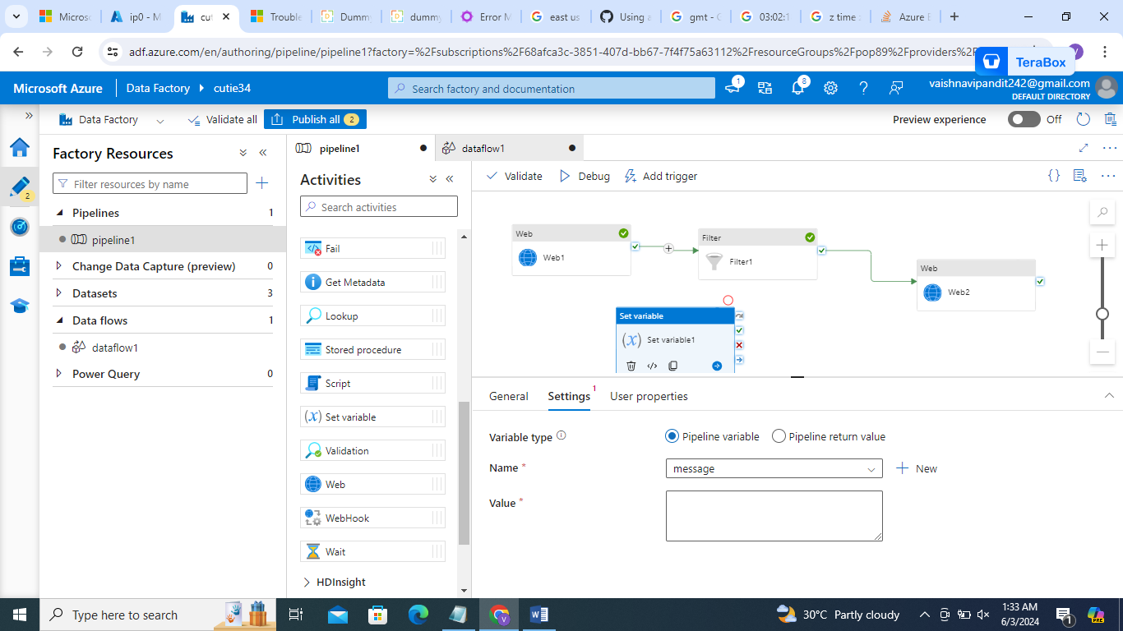

1. Now click on after last activity in pipeline and connect it to set variable

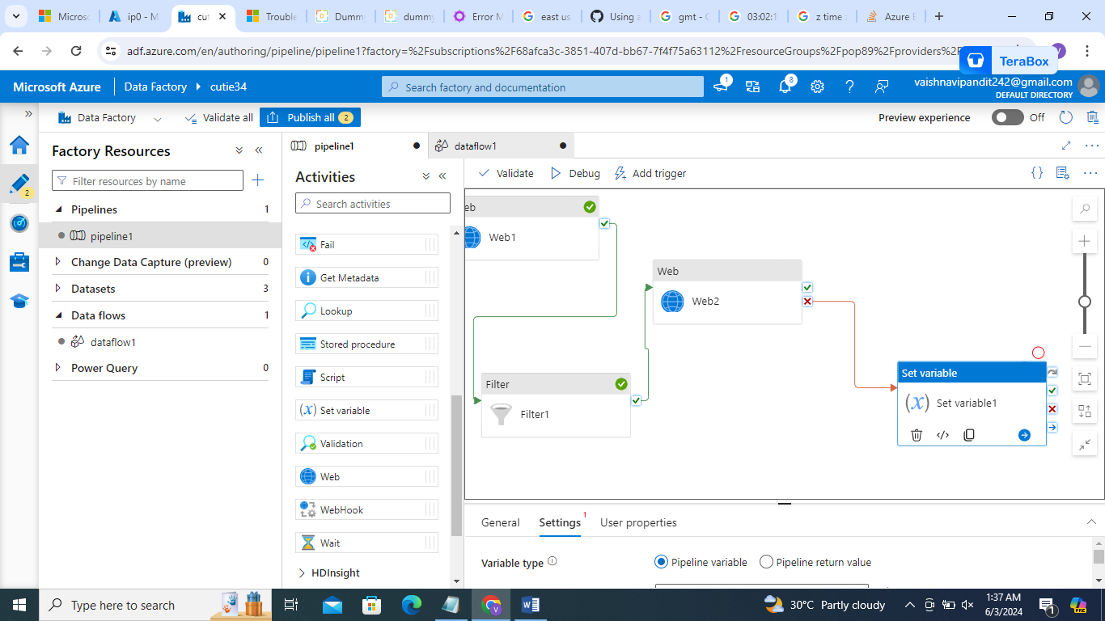

1. Value->add dynamic content->last activity output.error[0].Message

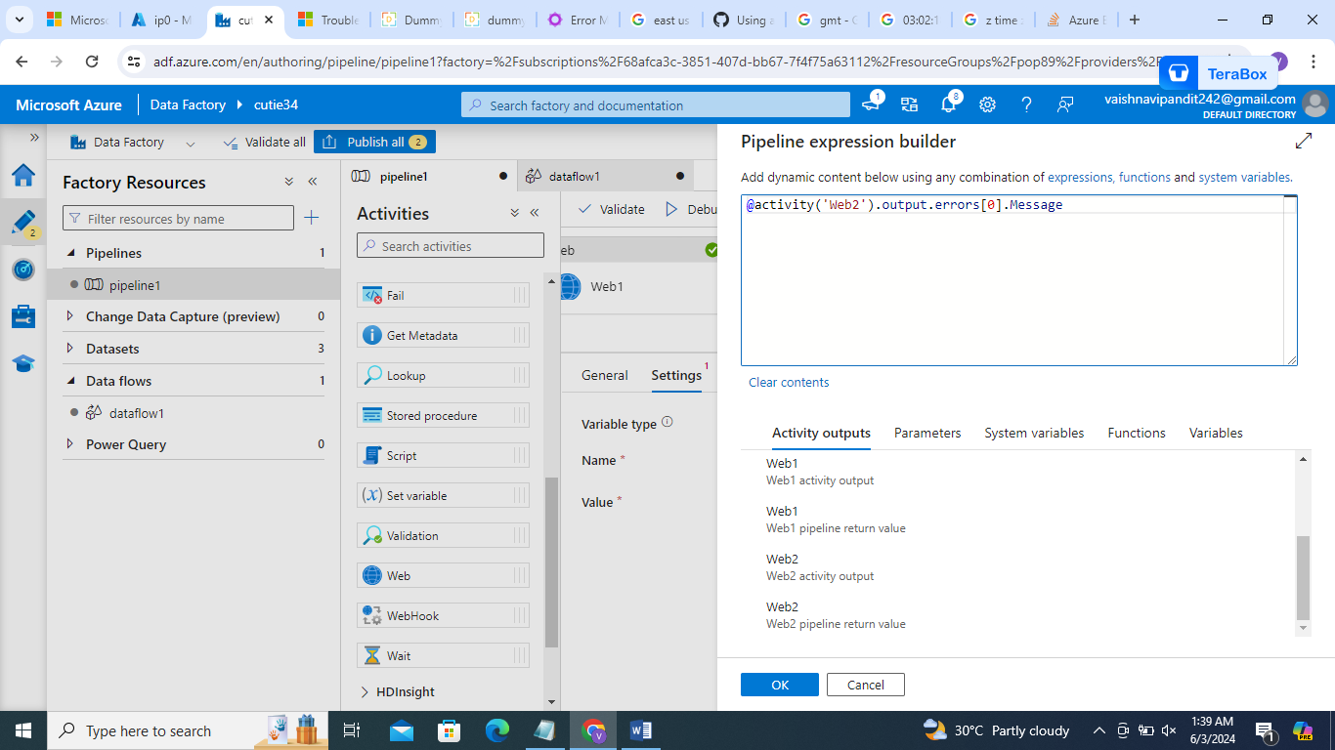

1. Now go to logic apps

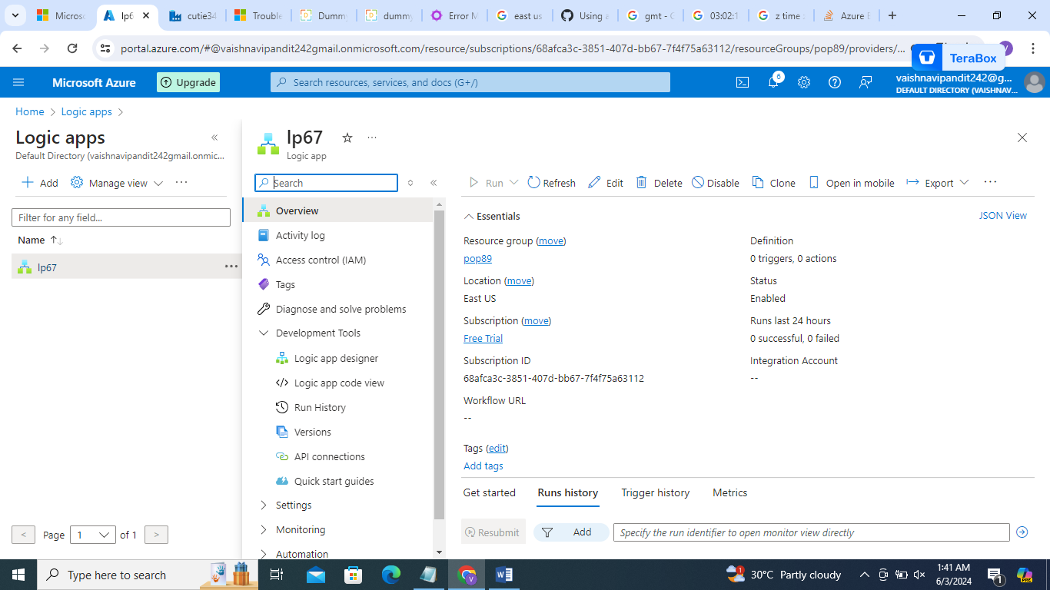

1. Go to development tools->logic app designer

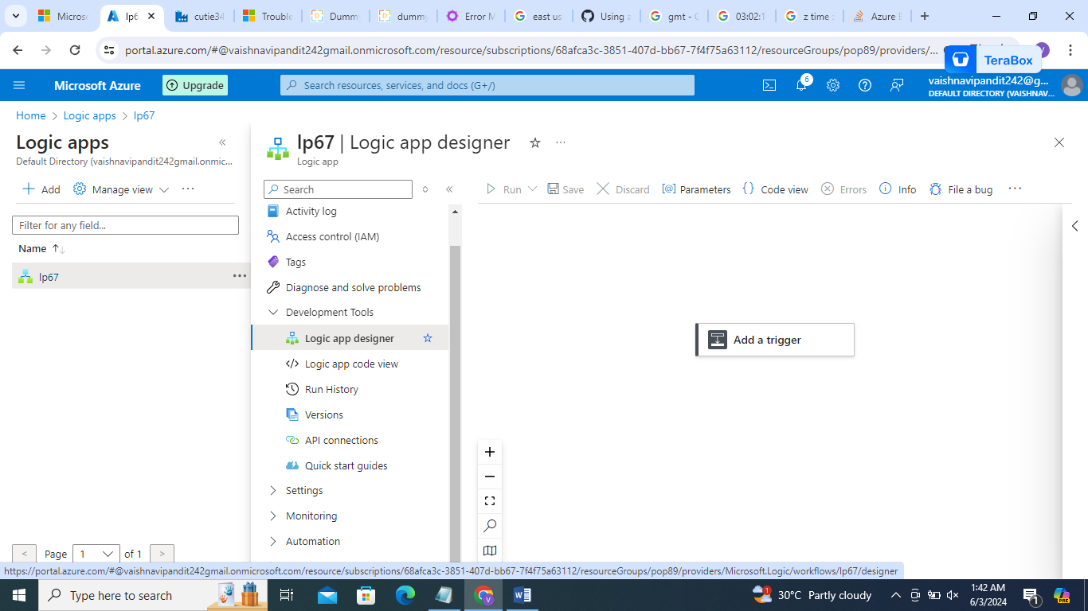

1. Click on add trigger->search http request

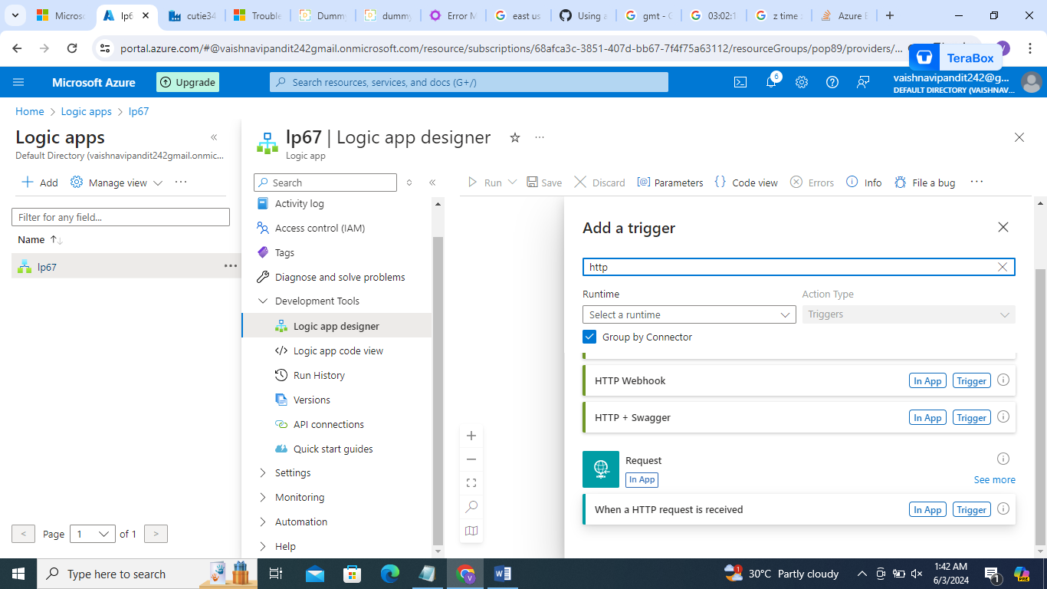

1. Click on http request

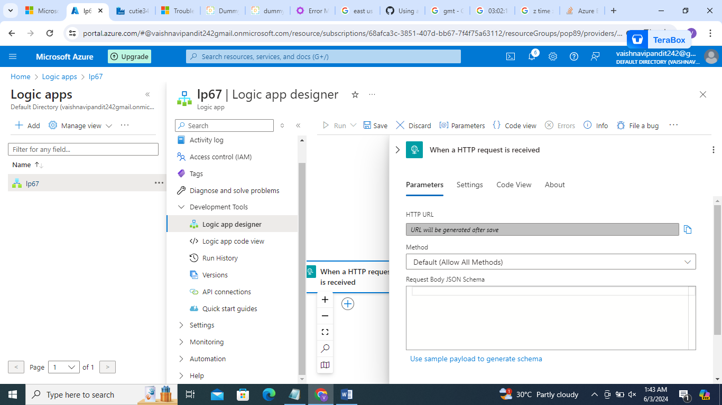

1. Now add method put

In body 🡪use sample payload

Write

{

"datafactoryname":"@pipeline().DataFactory",

"Pipelinename":"@pipeline().Pipeline",

"pipeleinerunid":"@pipeline().RunId",

"errormessage":"@activity('Web2').output.errors[0].Message"

}

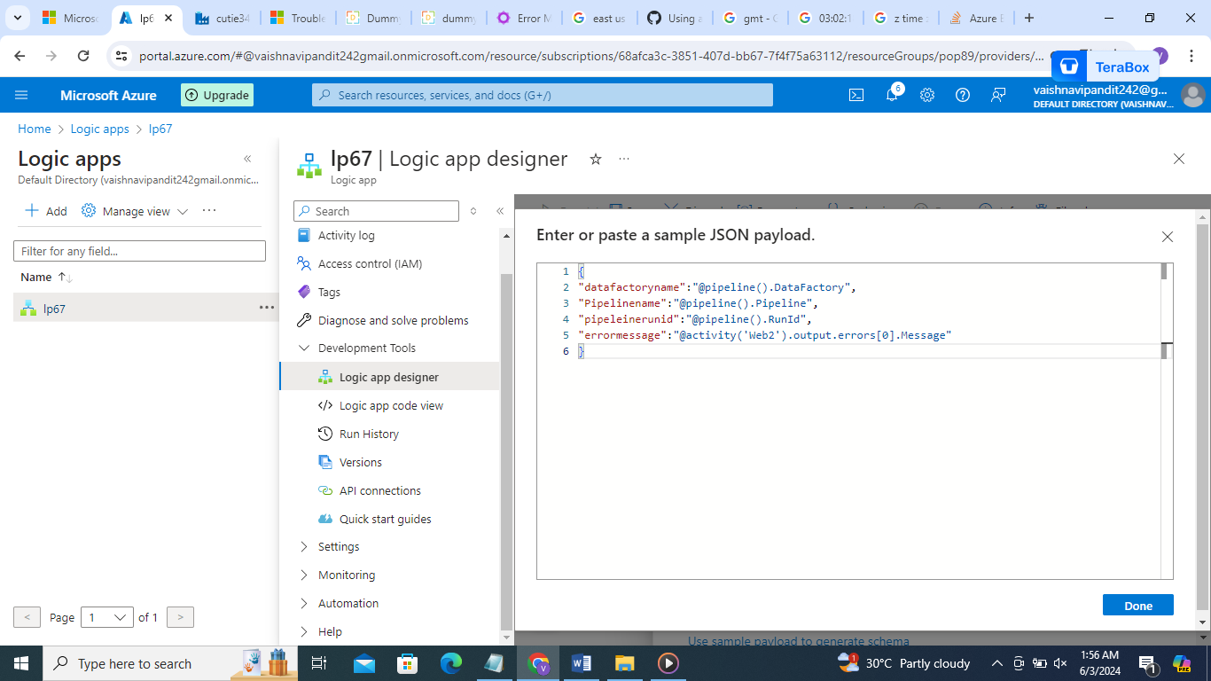

1. It will generate json

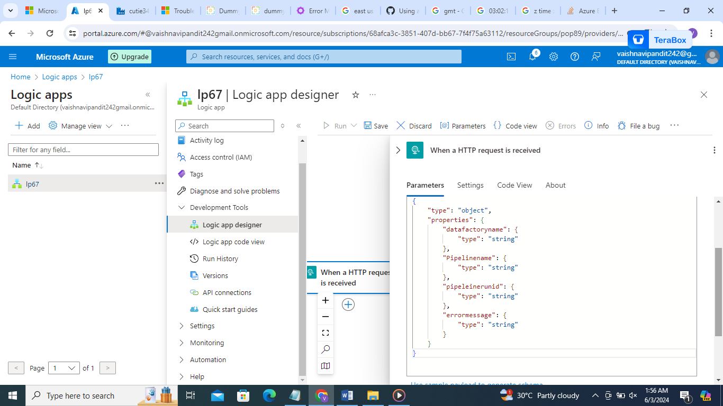

1. Now click +on trigger ->add action

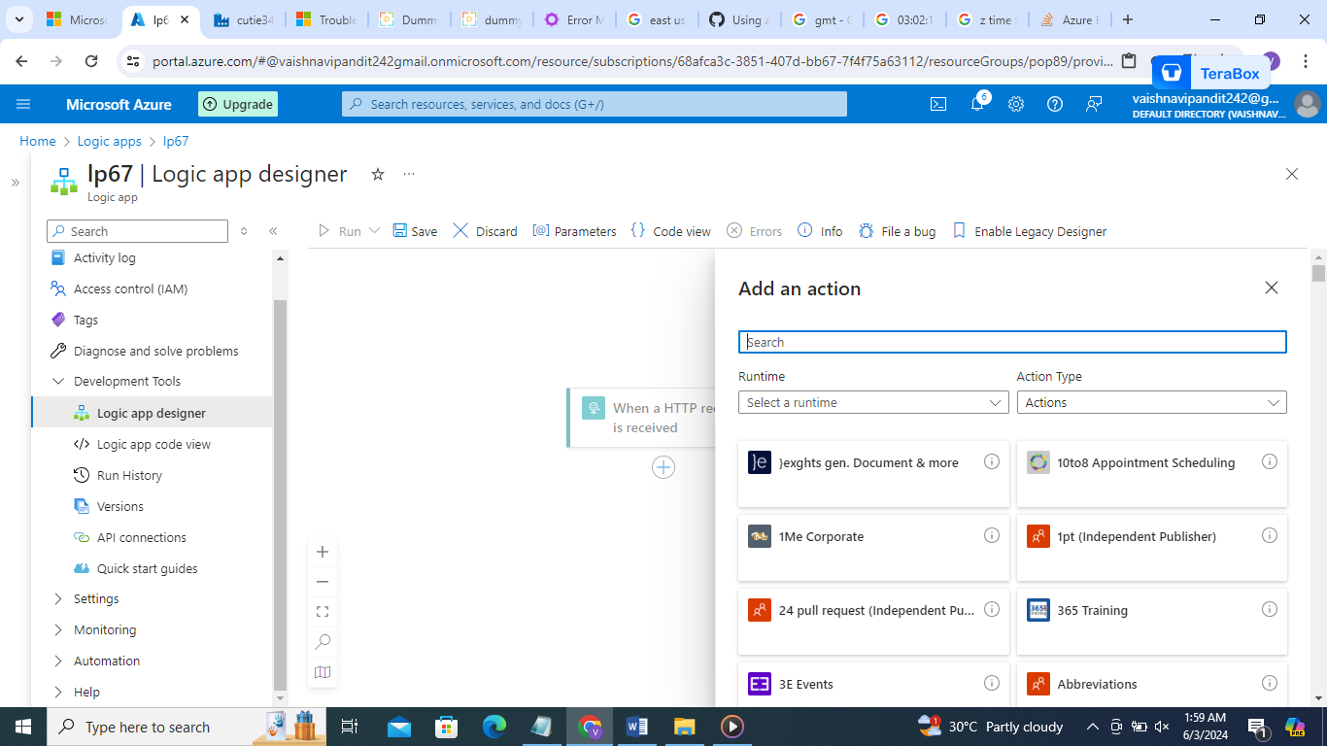

1. Go to gmail

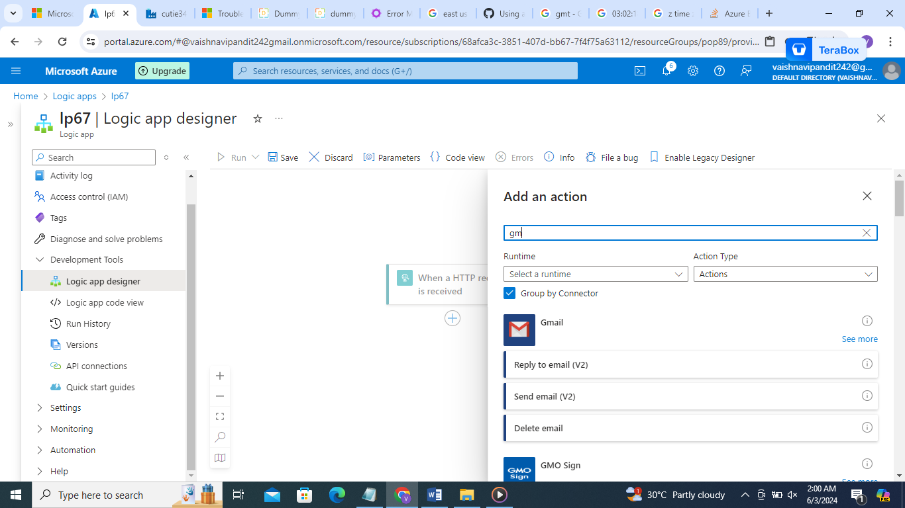

1. Go to send mail add email address

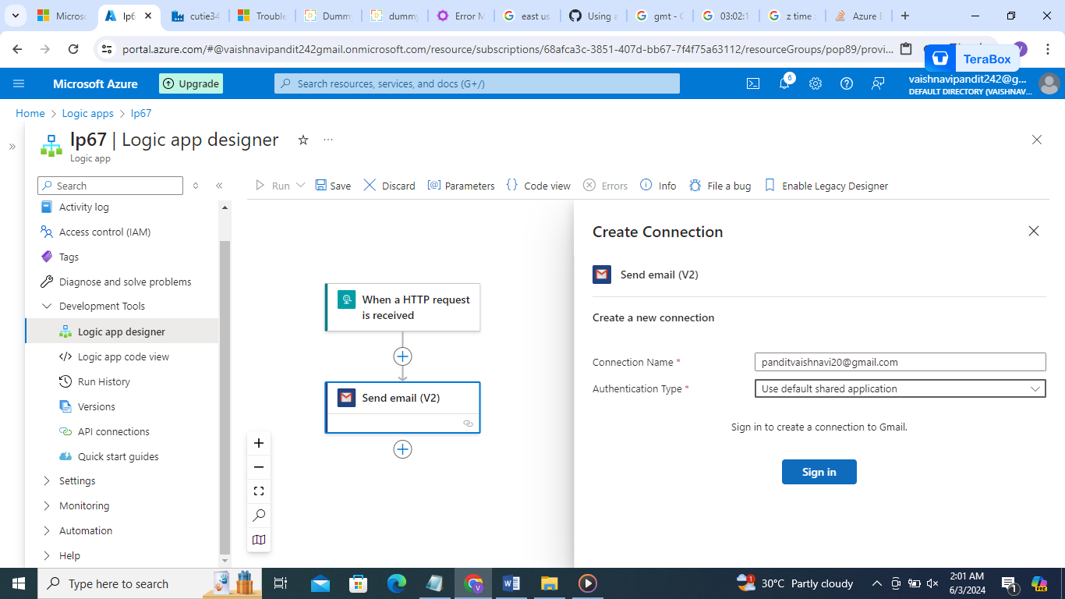

1. Now establish connection with gmail

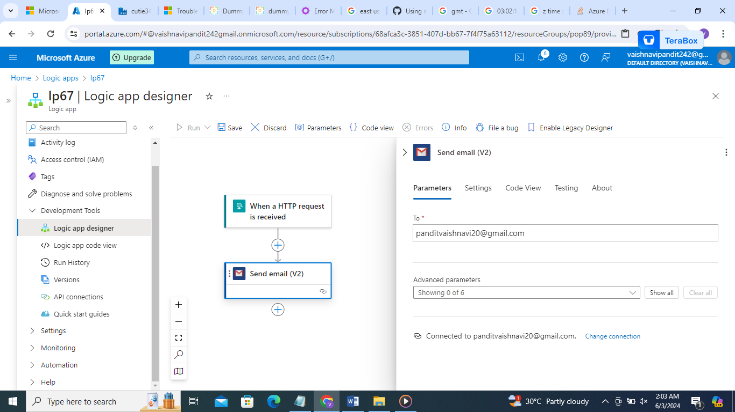

1. Go to advanced parameter add subject,body

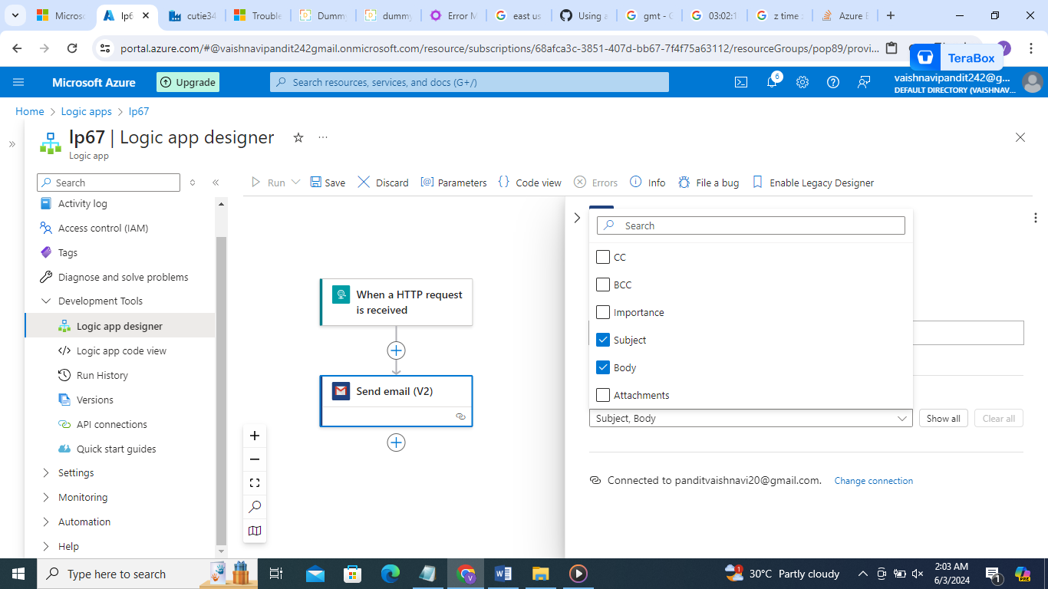

1. Add subject Pipeline failed

And body

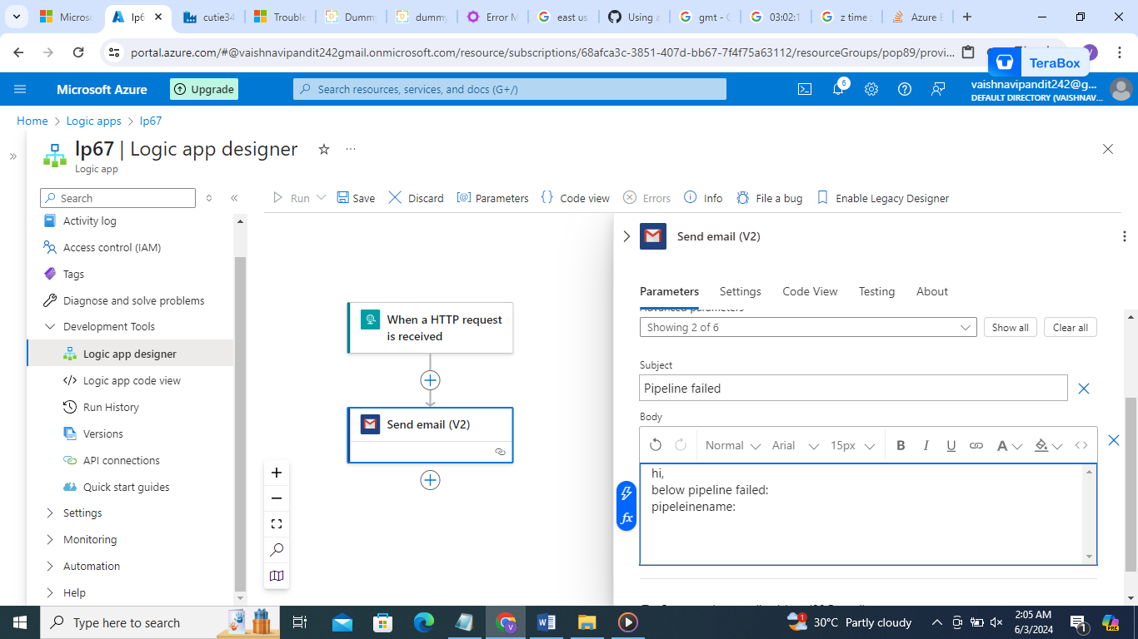

1. Now in body when you want to add pipeline name,datafactoryname and all

Go to fx sign after the box

Go to dynamic content

And add the parameters

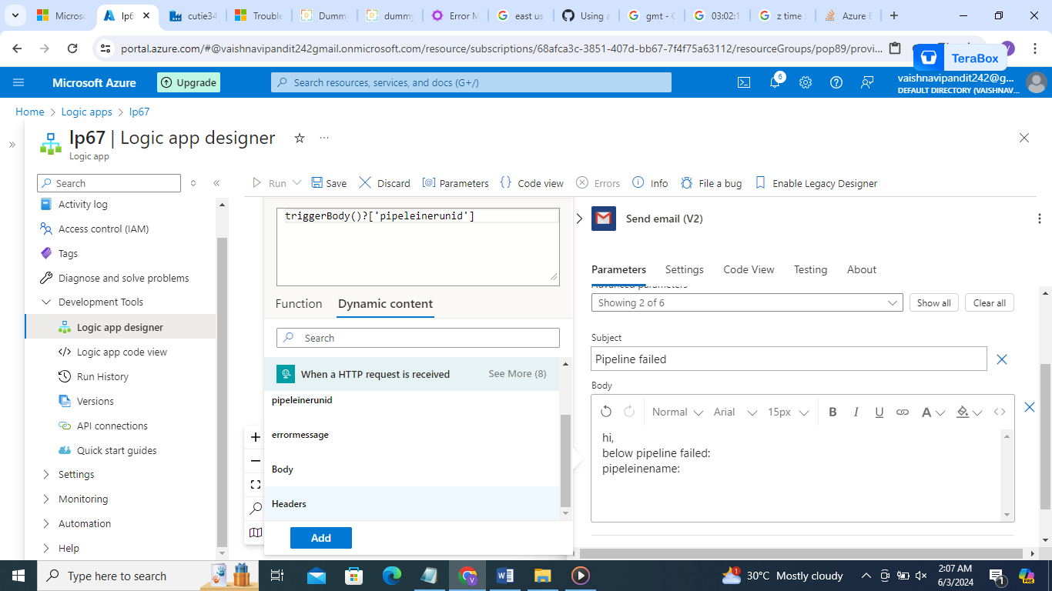

1. It will look like this

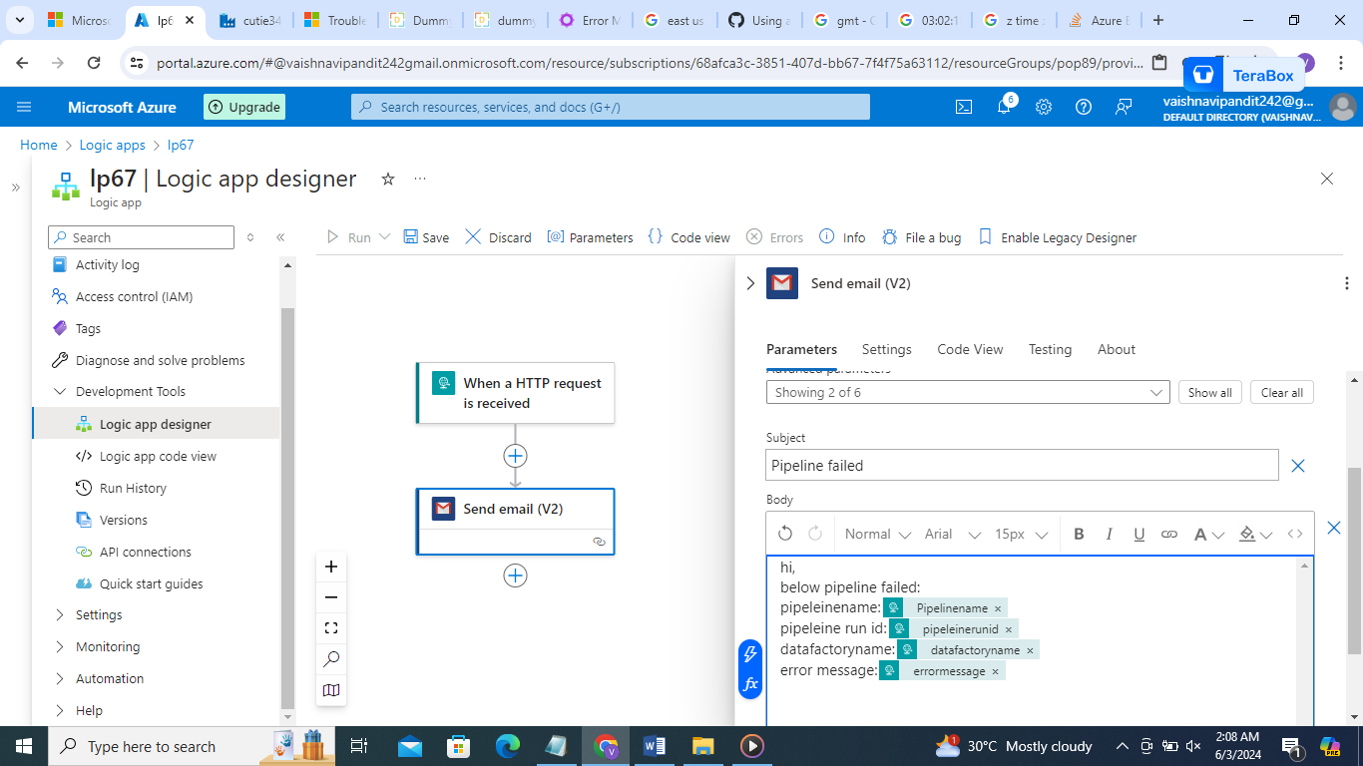

1. Now click on save at upper side
2. Now the url will be generated in http request copy that

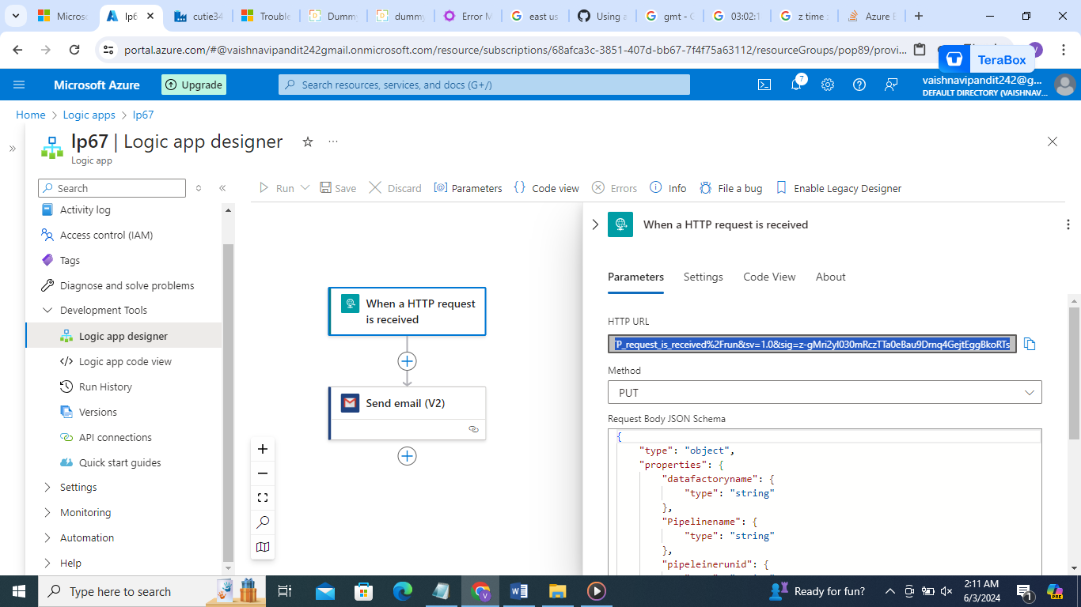

1. Now go to df

Create web activity

In url paste http request url

Method=put

In body =

{

"datafactoryname":"@pipeline().DataFactory",

"Pipelinename":"@pipeline().Pipeline",

"pipeleinerunid":"@pipeline().RunId",

"errormessage":"@activity('Web2').output.errors[0].Message"

}

1. Now publish and debug

